**Instructions: VIT-AP UNIVERSITY, ANDHRA PRADESH**

**Lab Sheet 6 : Time picker, Date Picker**

**Academic year:** 2021-2022  **Branch/ Class:** B.Tech

**Semester:** Fall  **Date: 19-10-2022**

**Faculty Name:** Dr. K.Rajesh  **School:** SCOPE

NAME: REGNO:

**\*\*\*\*\*\*\*\*\*\*\*\*\*\*\*\*\*\*\*\*\*\*\*\*\*\*\*\*\*\*\*\*\*\*\*\*\*\*\*\*\*\*\*\*\*\*\*\*\*\*\*\*\*\*\*\*\*\*\*\*\*\*\*\*\*\*\*\*\*\*\*\*\*\*\*\*\*\*\*\*\*\*\*\*\*\*\*\*\*\*\*\*\*\*\*\*\*\*\*\*\*\*\*\*\*\***

* Fill your Name and REGNO.
* Complete the program, add the code java and XML, input and output Screenshots after the question on the same document.
* Save this File name with your **registerno**_**lab6**

**eg 18ABC1234_LAB6.pdf**

* Upload it in assignment ->LAB6 in MS TEAM

1.Deagin an app to schedule three events. Add time picker to the App, choose time and when click set, display the time in the respective event.

2. Design an App for a Dialog based TimePicker.

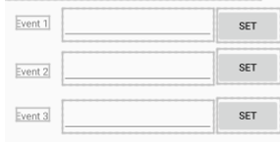

When ever SET button is clicked a timepicker should pop on choosing the date, it should set the date in the EditText and disappear.

2. Similarly set 3 dates.